Name: Viet Tran
Student ID: 25216938
Date: 12/20/2025

Breast Cancer Gene Expression Analysis

1. Background

1.1. Problem
Breast cancer is a malignant disease characterized by the uncontrolled proliferation of abnormal cells in breast tissue, most commonly arising from the milk ducts or lobules. These cells can invade surrounding tissues and metastasize to distant organs, contributing to disease morbidity and mortality (WHO, 2025). Breast cancer is the most frequently diagnosed cancer among women worldwide, with approximately 2.3 million new cases reported annually (WHO, 2025).

Breast cancer incidence increases with age, with most diagnoses occurring after age 50 and peak incidence between 60 and 70 years (WHO, 2025). Younger women under 40 account for approximately 5 - 7% of cases. Globally, a substantial proportion of patients are diagnosed at advanced stages (III–IV), particularly in resource-limited settings, due to inadequate screening, low disease awareness, and the asymptomatic nature of early-stage disease (Cleveland Clinic, 2023; WHO, 2025).

1.2. Overview About ERBB2
The ERBB2 gene encodes human epidermal growth factor receptor 2 (HER2), a 185-kDa transmembrane receptor tyrosine kinase belonging to the EGFR family. ERBB2 amplification or overexpression occurs in approximately 30% of breast cancers and is associated with aggressive tumor behavior, increased metastatic potential, and poorer clinical outcomes (Slamon et al., 1989; Tan and Yu, 2013). Aberrant ERBB2 signaling disrupts normal cell-cycle regulation and survival pathways, making HER2-positive breast cancer a biologically and clinically distinct subtype (Hung et al., 1986).

1.3. Analysis Direction
In this study, we analyzed the TCGA Breast Invasive Carcinoma (TCGA-BRCA PanCancer Atlas) dataset obtained from cBioPortal, comprising multi-omics data from 1,084 primary breast cancer patients. We focused on RNA-seq gene expression, copy number aberrations (CNA), and clinical metadata to address three key questions:
- Which genes are differentially expressed between HER2-amplified and non-amplified tumors?
- Which biological pathways are enriched among these genes?
- How do these pathways contribute to oncogenic processes in HER2-positive breast cancer?
Due to mismatched sample sizes across datasets, preprocessing and harmonization of patient identifiers were required prior to downstream analyses.

2. Methodology

2.1. Data Preprocessing
The RNA-seq dataset contained normalized expression values for 20,531 genes across 1,082 tumor samples, with gene symbols and Entrez Gene IDs provided. The CNA dataset included discrete copy-number calls (–2 to +2) for 25,128 genes across 1,072 samples. The clinical dataset comprised 1,084 patients and included demographic information, tumor characteristics, and survival outcomes.

Because sample counts differed across datasets, we performed data preprocessing to harmonize patient identifiers. The first four rows of the clinical dataset, which contained column metadata, were removed. Patient IDs were standardized to a consistent TCGA format to ensure accurate alignment. Only patients present in all three datasets were retained, resulting in a final cohort of 1,068 patients.

We then constructed a metadata matrix including age at diagnosis, disease stage, and ERBB2 amplification status. Age was encoded as early (<50 years) or late (≥50 years). ERBB2 amplification status was also encoded as a binary variable. Disease stage was modeled as an ordinal factor (Stages I–IV), with unclassified stage values (Stage X) and other missing entries imputed as 0 for downstream analyses.

2.2. Differential Expression Analysis
We performed differential gene expression analysis using the DESeq2 R package (Love, Huber and Anders, 2014). Raw counts were normalized using the median-ratio method, and negative binomial generalized linear models were fitted to compare ERBB2-amplified and non-amplified tumors. Genes with Benjamini-Hochberg-adjusted $p-values < 0.05$ were considered significantly differentially expressed and were classified as over- or under-expressed based on $log2 fold change$ direction.

2.3. Pathway Enrichment Analysis
Functional enrichment analyses were conducted separately for over- and under-expressed genes. Gene Ontology enrichment was performed using clusterProfiler with org.Hs.eg.db annotation (Xu et al., 2024; Carlson, n.d.). KEGG and Reactome pathway enrichment analyses were conducted after converting gene symbols to Entrez IDs (Yu and He, 2016). Multiple testing correction was applied using the Benjamini–Hochberg method, with $adjusted p-values <0.05 \& q-values < 0.05$ to be considered significant. Enrichment results were visualized using dot plots generated by the enrichplot package, displaying the top enriched GO terms or pathways for each gene set (Yu, 2025).

3. Results
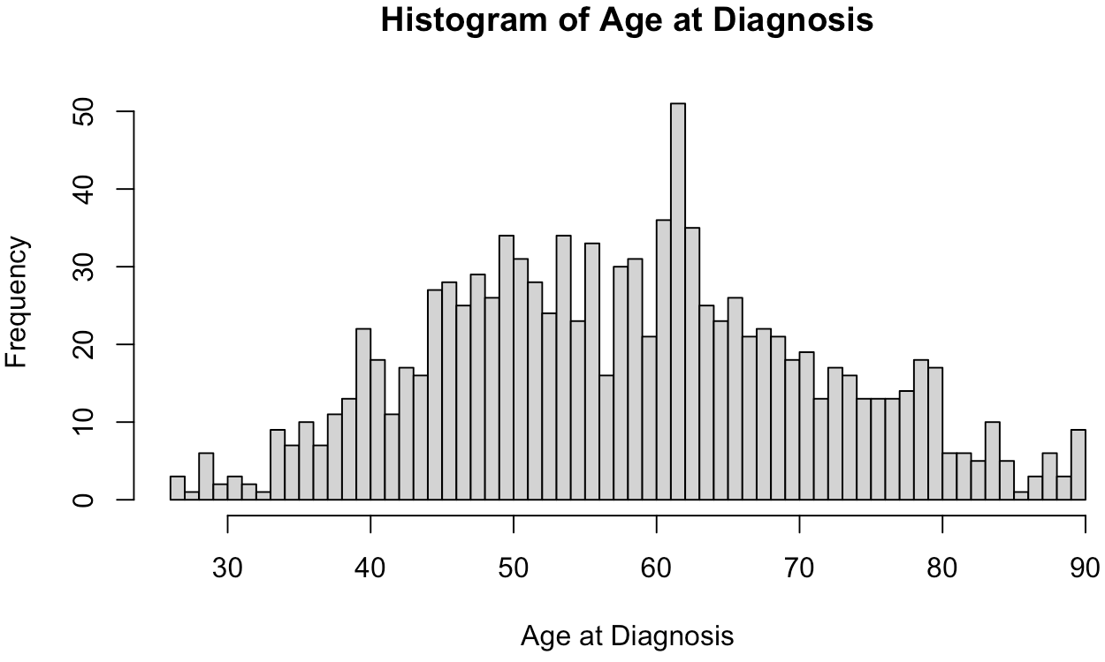
Figure 1. The distribution of age when getting diagnosed. Most cases lie in the age range from 50 to 65.

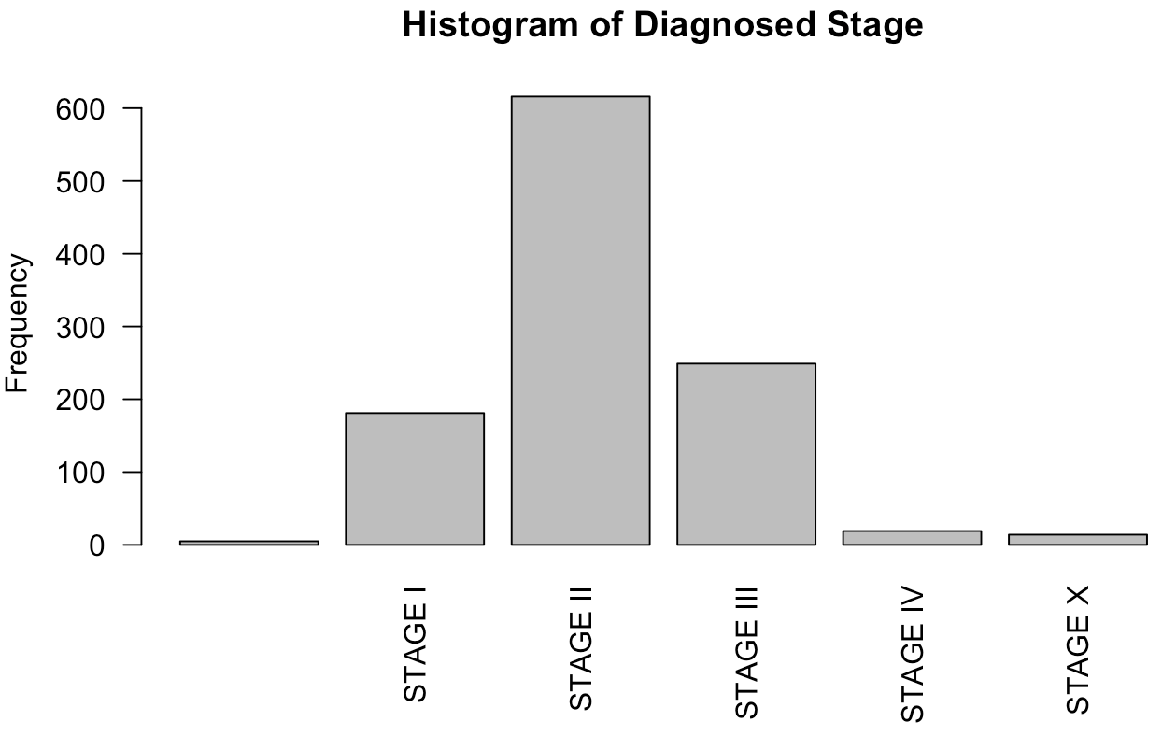
Figure 2. Distribution of the diagnosed stage. Most cases get diagnosed at stage II or III, which suggests that they get diagnosed late.

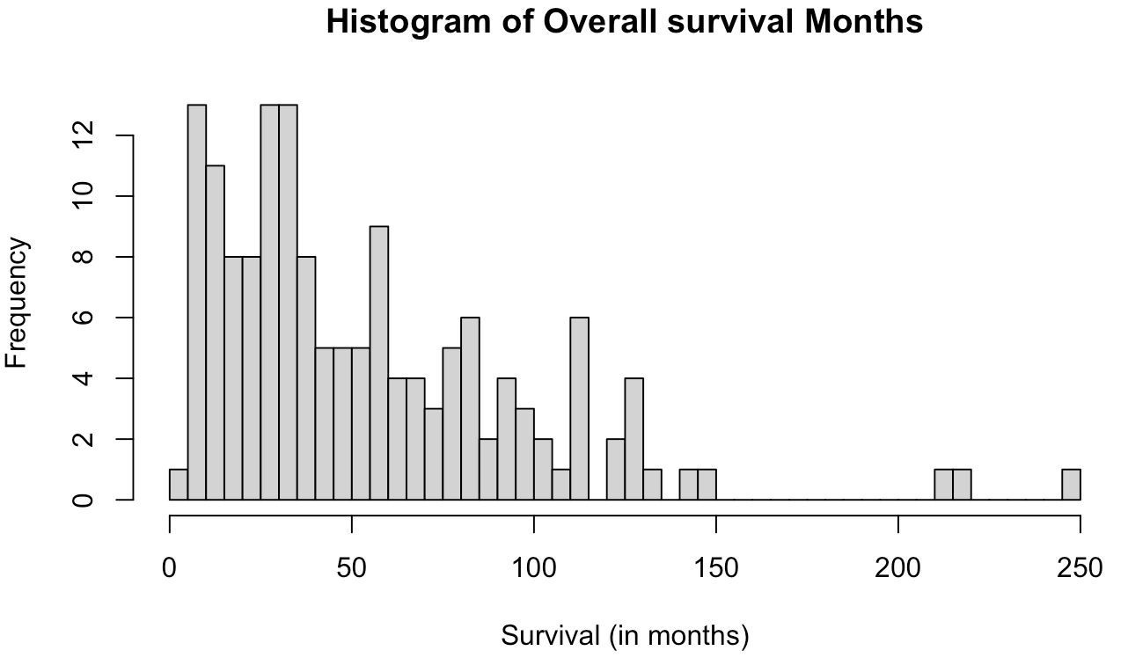
Figure 3. Distribution of the overall survival times in months of all patients. Each bar represents the number of patients who die in a 5 month period. Most people survived at least 5 months to almost 8 years.

We first examined the demographic and clinical characteristics of the patient cohort. As shown in Figure 1, the majority of patients were diagnosed after the age of 50, with the highest concentration occurring between 50 and 65 years. Most patients were diagnosed at Stage II, while Stage IV diagnoses were relatively rare, suggesting that a substantial proportion of cases were identified at earlier stages of disease progression. Survival time following diagnosis exhibited considerable variability, ranging from approximately 5 months to nearly 8 years. The mean survival duration across the cohort was 4.5 years.

3.1. Differential Expression Analysis ERBB2 Amplified and Not Amplified
Gene | baseMean | log2FoldChange | Adjusted p-value
ERBB2 | 18,302.597 | 2.845 | 2.26 × 10⁻²⁸⁹
PSMD3 | 5,074.459 | 2.058 | 2.25 × 10⁻²⁷⁴
STARD3 | 1,703.229 | 2.193 | 2.79 × 10⁻²⁶⁴
C17orf37 | 1,972.660 | 2.433 | 4.51 × 10⁻²⁵⁵
GRB7 | 1,309.927 | 2.635 | 5.85 × 10⁻²⁴⁵
PGAP3 | 1,929.690 | 2.291 | 4.25 × 10⁻²²⁴
ORMDL3 | 3,982.237 | 2.072 | 6.68 × 10⁻²¹³
MED1 | 2,543.443 | 1.837 | 1.82 × 10⁻²⁰³
MSL1 | 3,083.400 | 1.411 | 3.20 × 10⁻¹⁷⁷
FBXL20 | 244.919 | 1.638 | 4.38 × 10⁻¹⁷⁴
Table 1. Top 10 genes with highest adjusted p-value for the gene expression analysis

Table 1 presents the ten genes with the lowest $adjusted p-values$ from the differential expression analysis comparing ERBB2-amplified and non-amplified breast cancer samples. As expected, ERBB2 itself was among the most significantly overexpressed genes, reflecting the biological validity of the stratification based on ERBB2 amplification status.

Notably, six of the top ten differentially expressed genes (PSMD3, STARD3, C17orf37, GRB7, PGAP3, and ORMDL3) exhibited more than 4-time increase in expression in the ERBB2-amplified group relative to the non-amplified group. These genes are located within or proximal to the ERBB2 amplicon on chromosome 17q12, suggesting coordinated co-amplification and co-expression driven by regional genomic alterations (Sahlberg et al., 2012). The table 2 below summarizes the function of each gene and their relevance to breast cancer.

Gene | Function
PSMD3 | Associates with white blood cell counts, neutrophil numbers, and even asthma susceptibility in diverse populations. PSMD3 contributes to the regulation of innate immunity and inflammatory processes (Ma'ayan Laboratory of Computational Systems Biology, 2016).
STARD3 | Encodes a cholesterol-binding membrane protein. This protein localizes to late endosomal organelles (LEs) and has an N-terminal domain that targets the protein to the LE membrane and a C-terminal domain with a cytoplasmic cholesterol-binding site (Fattah et al., 2021).
C17orf37 | Contains a functional CAAX motif and is post-translationally modified by protein geranylgeranyltransferase-I (GGTase-I). Geranylgeranylation of C17orf37 at the CAAX motif facilitates association of the protein to the inner leaflet of plasma membrane, enhances migratory phenotype of cells by inducing increased filopodia formation, and potentiates directional migration (Dasgupta et al., 2011).
GRB7 | Encodes a 535-amino acid protein (Growth factors binding protein-7 or GRB-7) that acts through its SH2 domain as an adaptor molecule (Pero et al., 2002; Han, Shen and Guan, 2001). GRB7 family members interact with a variety of proteins, including tyrosine kinase receptors, such as HER2 (Stein et al., 1994).
PGAP3 | Encodes a glycosylphosphatidylinositol (GPI)-specific phospholipase that primarily localizes to the Golgi apparatus. This ubiquitously expressed gene is predicted to encode a seven-transmembrane protein that removes unsaturated fatty acids from the sn-2 position of GPI (National Center for Biotechnology Information, 2025).
ORMDL3 | Involves in the ceramide metabolic process. Acts upstream of or within several processes, including negative regulation of B cell apoptotic process; negative regulation of ceramide biosynthetic process; and positive regulation of protein localization to nucleus (National Center for Biotechnology Information, 2025a).
Table 2. The functions of top 6 genes with highest adjusted p-value excluding ERBB2

Several of these genes have well-established functional links to HER2-positive breast cancer biology. PSMD3, a 26S proteasome subunit, is strongly co-expressed with HER2 (Kotoula et al., 2014). The combined silencing of PSMD3 and HER2 has been shown to exert additive inhibitory effects on tumor cell viability and proliferation, underscoring its contribution to proteostasis and survival in HER2-driven tumors (Kotoula et al., 2014; Sahlberg et al., 2012).

STARD3, which encodes a cholesterol-binding protein involved in intracellular cholesterol trafficking, is overexpressed in ERBB2-amplified tumors and may reflect metabolic adaptations that support membrane biosynthesis and rapid proliferation, consistent with the known dysregulation of cholesterol metabolism in breast cancer (Hölttä-Vuori et al., 2005; Charman et al., 2010; Danilo and Frank, 2012). C17orf37 (MIEN1), whose expression correlates with tumor grade, stage, and metastatic spread, is similarly upregulated, supporting its role in tumor invasion and aggressiveness (Dasgupta et al., 2009).

GRB7, an adaptor protein frequently co-amplified with ERBB2, participates in signaling pathways that regulate cell migration and proliferation through interactions with focal adhesion kinase (FAK). Its association with enhanced motility and cell-cycle progression further implicates GRB7 in metastatic behavior in HER2-positive tumors (Shen and Guan, 2001; Han, Shen, and Guan, 2001; Jacot et al., 2013).

PGAP3 and ORMDL3 also show consistent overexpression in ERBB2-amplified samples and have been linked to clinically relevant features, including lymph node metastasis, immune infiltration, recurrence-free survival, and overall survival, suggesting potential prognostic relevance (Hao et al., 2023; Mamoor, 2024; Mamoor, 2024a).
In summary, these findings demonstrate that ERBB2 amplification is associated with coordinated overexpression of multiple neighboring genes with established roles in tumor proliferation, metabolism, migration, and metastasis. To further characterize the functional consequences of these transcriptional changes, we next performed pathway and functional enrichment analyses on the differentially expressed genes.

3.2. Pathway Enrichment Analysis

3.2.1. Gene Ontology Enrichment Analysis
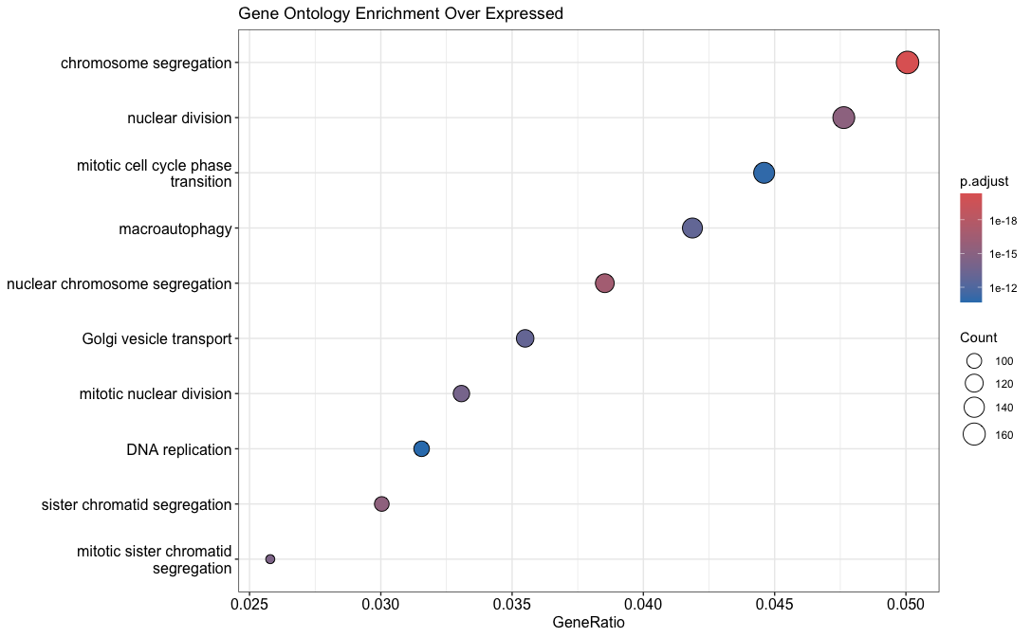
Figure 4. GO Biological Process Pathways Enriched Among Over-Expressed Genes. Dot plot showing Gene Ontology (GO) Biological Process enrichment results for over-expressed genes. The x-axis represents the GeneRatio (proportion of input genes associated with each pathway), dot size corresponds to the number of genes mapped to each pathway, and color indicates the adjusted p-value (Benjamini–Hochberg corrected), with darker colors representing greater statistical significance.

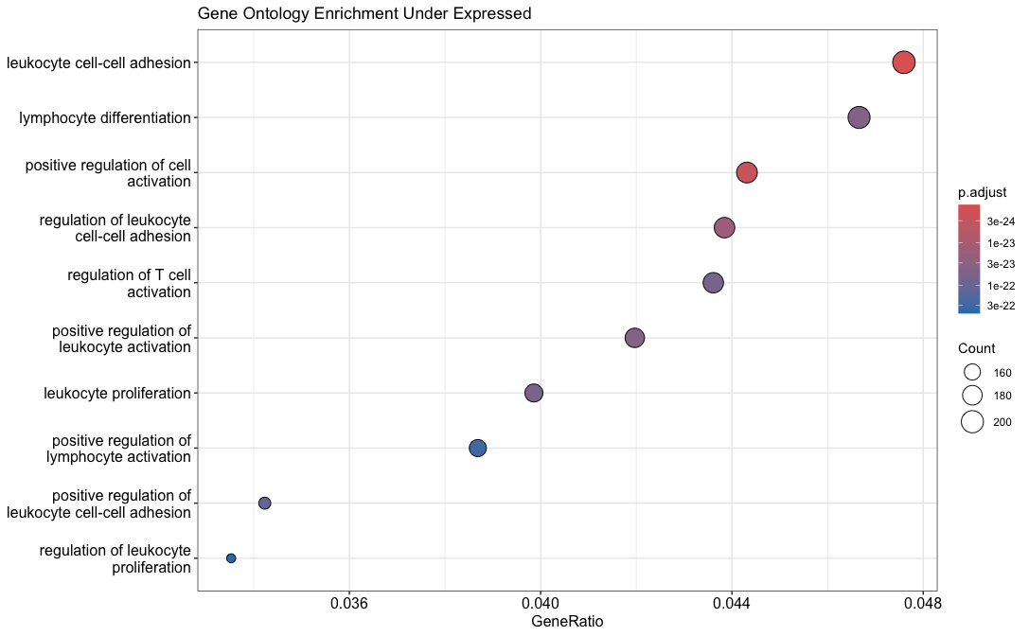
Figure 5. GO Biological Process Pathways Enriched Among Under-Expressed Genes.

As shown in Figures 4 and 5, immune-related pathways are significantly enriched among under-expressed genes, whereas cell-cycle and mitotic pathways are enriched among over-expressed genes. This pattern is consistent with known features of breast cancer biology and reflects transcriptional alterations affecting proliferative and immune-related processes.

Enrichment of the cell cycle associated pathways, including DNA replication, chromosome segregation, and mitotic division, indicates coordinated overexpression of genes involved in proliferation and genome duplication. Dysregulation of these processes is a hallmark of cancer and contributes to replicative stress, chromosomal instability, and tumor progression (Hanahan and Weinberg, 2011). In addition, enrichment of macroautophagy-related pathways suggests transcriptional alterations in stress-adaptation mechanisms, which cancer cells often exploit to support survival under metabolic or therapeutic stress (Levy, Towers, and Thorburn, 2017).

In contrast, pathways enriched among under-expressed genes are predominantly immune-related, including leukocyte adhesion, T-cell activation, and lymphocyte differentiation. Reduced expression of genes in these pathways may reflect diminished immune infiltration or altered immune activation within the tumor microenvironment. These patterns have been associated with poorer outcomes in breast cancer (Salgado et al., 2015).

These GO enrichment results highlight a transcriptional background characterized by enhanced proliferative programs and reduced immune-related gene expression in ERBB2-amplified tumors. To further analyze the biological processes underlying these changes, we next performed pathway enrichment analysis using the KEGG database.

3.2.2. KEGG Pathway Enrichment Analysis
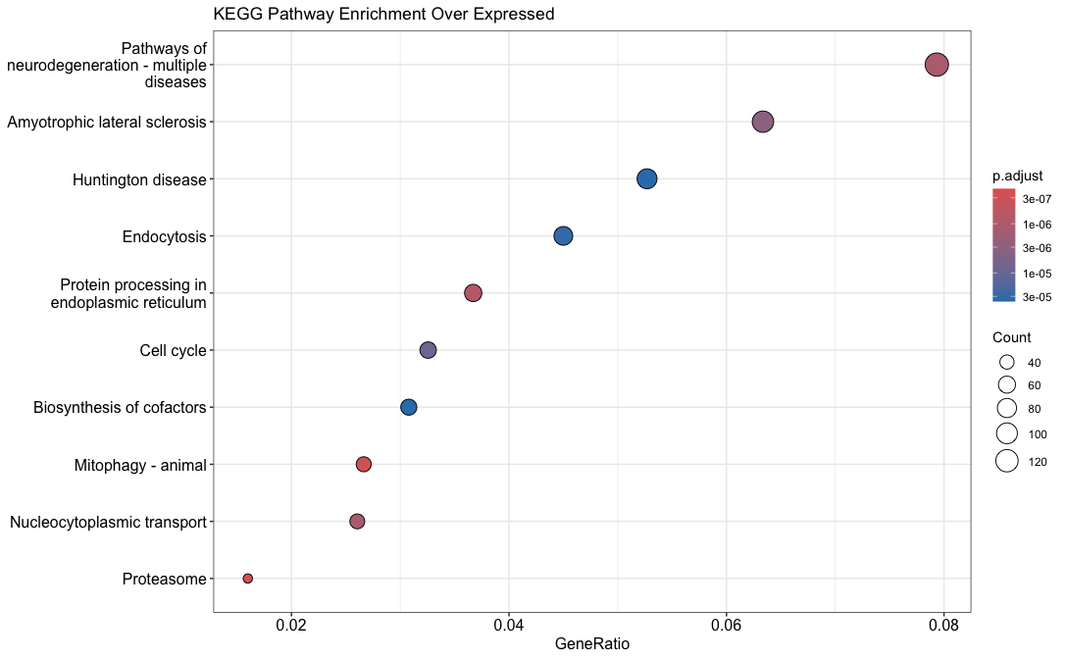
Figure 6. KEGG Biological Process Pathways Enriched Among Over-Expressed Genes. Dot plot showing KEGG pathway enrichment results for overexpressed genes. The x-axis represents the GeneRatio (proportion of input genes associated with each pathway), dot size corresponds to the number of genes mapped to each pathway, and color indicates the adjusted p-value (Benjamini–Hochberg corrected), with darker colors representing greater statistical significance.

As shown in Figure 6, multiple KEGG pathways enriched among over-expressed genes are associated with core cancer-related cellular processes. Enrichment of the proteasome and protein processing in the endoplasmic reticulum pathways is consistent with the heightened proteostatic demands of malignant cells. Rapid tumor cell proliferation requires sustained protein turnover to maintain proteome integrity and regulate key oncogenic and cell-cycle-related proteins, thereby supporting continued growth and survival (Byers et al., 2023).

The cell cycle pathway was also significantly enriched among over-expressed genes, reflecting increased expression of genes involved in DNA replication, mitosis, and cell-cycle progression. Dysregulation of these processes, as mentioned in GO analysis, represents a central hallmark of cancer and contributes to uncontrolled proliferation, replicative stress, and genomic instability (Hanahan and Weinberg, 2011). In addition, enrichment of the mitophagy pathway suggests transcriptional alterations in mitochondrial quality-control mechanisms. Increased expression of mitophagy-related genes may enable tumor cells to remove damaged mitochondria, limit reactive oxygen species (ROS) accumulation, and adapt metabolically to cellular stress, thereby promoting tumor cell survival (Deepak et al., 2024).

Enrichment of pathways related to nucleocytoplasmic transport highlights potential dysregulation of intracellular trafficking in breast cancer. Aberrant nucleocytoplasmic transport has been implicated in altered localization and function of transcription factors and hormone receptors, including estrogen receptor-alpha, contributing to changes in gene regulation and therapeutic resistance (Tecalco-Cruz et al., 2017; Conforti et al., 2015). Similarly, enrichment of the endocytosis pathway reflects transcriptional changes in membrane trafficking processes that support nutrient uptake, receptor internalization, and oncogenic signaling, all of which are essential for meeting the metabolic and proliferative demands of tumor cells (Chan and Cömert Kural, 2024; Guo et al., 2024; Yarwood et al., 2020).

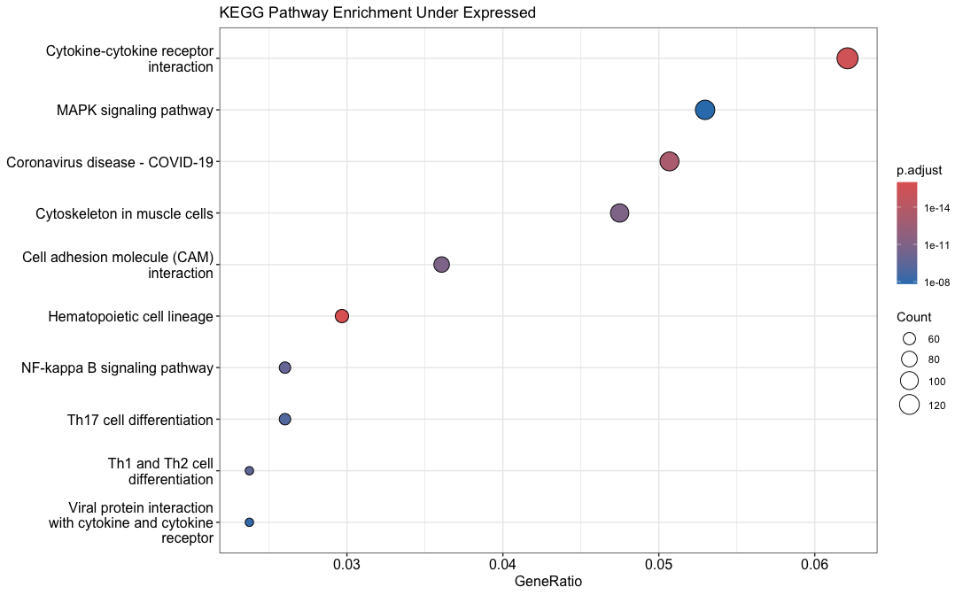
Figure 7. KEGG Biological Process Pathways Enriched Among Under-Expressed Genes.

In contrast, KEGG pathways enriched among under-expressed genes were predominantly immune-related, including hematopoietic cell lineage, cytokine-cytokine receptor interaction, Th1 and Th2 cell differentiation, Th17 cell differentiation, and the NF-kappa B signaling pathway (Figure 7). Reduced expression of genes within these pathways suggests transcriptional alterations affecting immune-associated processes within the tumor microenvironment, potentially reflecting diminished immune activation or immune evasion mechanisms (Ubellacker et al., 2018; Korkaya, Liu, and Wicha, 2011).

Finally, enrichment of pathways related to the cytoskeleton in muscle cells among under-expressed genes may indicate loss of normal tissue differentiation or remodeling of stromal or contractile programs during tumor progression, consistent with reported patterns of cancer-associated tissue remodeling (Figure 7; Liu, Liu, and Xiong, 2025). Enrichment of cell adhesion molecule (CAM) interactions and integrin signaling pathways further suggests transcriptional alterations affecting cell-cell and cell-matrix interactions, which play key roles in tumor invasion and metastatic dissemination (Figure 7; Darang et al., 2023).

3.2.3. Reactome Pathway Enrichment Analysis
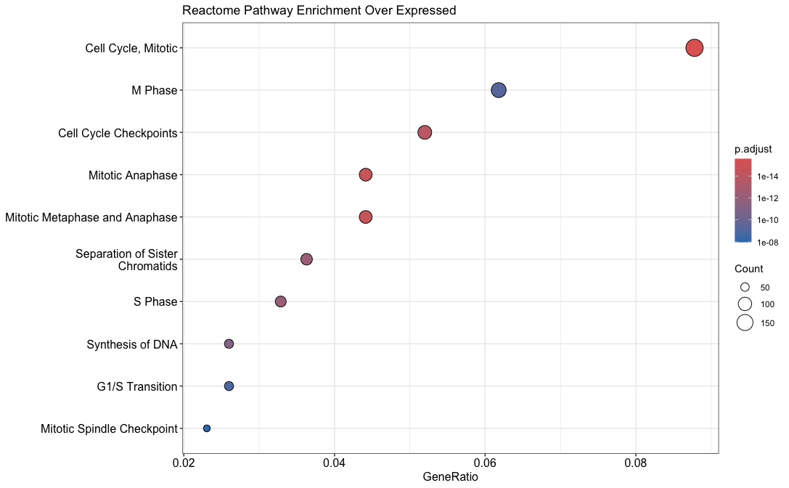
Figure 8. Reactome Pathways Enriched Among Over-Expressed Genes. Dot plot showing Reactome pathway enrichment results for overexpressed genes. The x-axis represents the GeneRatio (proportion of input genes associated with each pathway), dot size corresponds to the number of genes mapped to each pathway, and color indicates the adjusted p-value (Benjamini–Hochberg corrected), with darker colors representing greater statistical significance.

The top 10 most significant Reactome pathways were predominantly related to cell-cycle regulation, such as M phase, cell cycle checkpoints, DNA synthesis (S phase), mitotic anaphase (Figure 8). Enrichment of these pathways indicates transcriptional overexpression of genes involved in cell-cycle progression and mitosis in ERBB2-amplified tumors, reflecting increased proliferative activity.
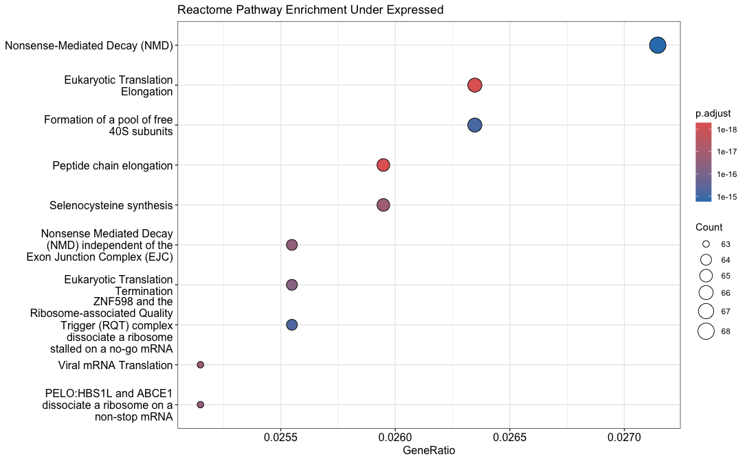
Figure 9. Reactome Pathways Enriched Among Under-Expressed Genes.

Eukaryotic translation elongation, eukaryotic translation, and peptide chain elongation are enriched pathways among under-expressed genes, which represent core ribosomal processes required for protein synthesis (Figure 9). Deregulation of ribosomal proteins (RPs) can disrupt ribosome biogenesis and impair cell survival, growth, and proliferation (El Khoury and Nasr, 2021). Notably, many RPs have been reported to be aberrantly expressed in breast cancer, providing a possible explanation for the enrichment of protein synthesis-related pathways observed in figure 13 (El Khoury and Nasr, 2021).

Furthermore, enrichment of the selenocysteine synthesis pathway among under-expressed genes points to potential disruption of redox-regulatory mechanisms (Figure 9). Under physiological conditions, selenium is metabolized into selenocysteine (Sec), which is incorporated into selenoproteins involved in antioxidant defense and cellular stress responses (Shimada et al., 2022). Hughes et al. (2023) reported an inverse association between GPX3 (a selenoprotein) activity and premenopausal breast cancer risk, which supports the protective role for selenoproteins in breast cancer. Therefore, reduced expression of genes involved in selenocysteine biosynthesis may reflect diminished capacity for selenoprotein production, potentially increasing susceptibility to oxidative stress.

Consistent with these observations, enrichment of Reactome pathways related to viral mRNA translation, nonsense-mediated decay (NMD), and ribosome quality-control mechanisms among under-expressed genes suggests broader transcriptional alterations affecting mRNA surveillance, translation fidelity, and ribosome dynamics (Figure 9). Reduced expression of NMD-related genes may impair degradation of aberrant transcripts, allowing accumulation of faulty or truncated mRNAs that could influence oncogenic signaling, proteostasis, or immune recognition (Pan et al., 2025). Similarly, under-expression of ribosome rescue and quality-control pathways (such as PELO:HBS1L- and ABCE1-mediated ribosome recycling, ZNF598/RQT-mediated resolution of stalled ribosomes, and formation of free 40S subunits) indicates compromised handling of stalled or collided ribosomes and altered translational stress responses (Figure 9; Reactome, 2017; Morris, Cluet and Ricci, 2021).

3.3. Heatmap Analysis & PCA
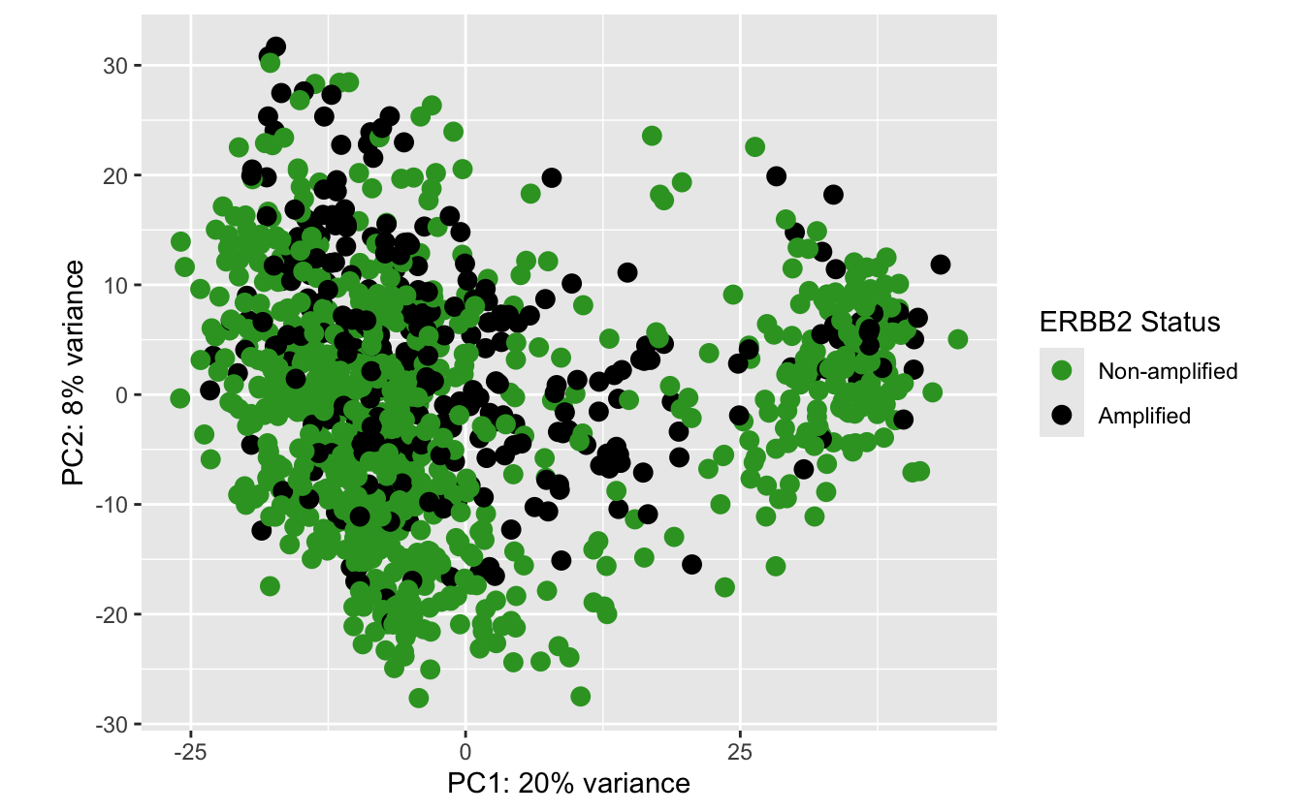
Figure 10. Principal Component Analysis (PCA) of RNA-seq Expression Profiles. Each point represents a tumor sample projected onto the first two principal components (PC1: 20% variance, PC2: 8% variance). Samples are colored by ERBB2 amplification status, where darker blue indicates ERBB2-amplified tumors and lighter colors indicate non-amplified tumors.

The principle component analysis only explains 28% of the total variance of the population. As we can see from figure 12, two groups ERBB2 amplified and non-amplified are not well separated. This suggests that ERBB2 amplification status, while biologically meaningful, explains only a small fraction of total gene-expression heterogeneity across these tumors. Hence, we suspect that there are other biological factors that could contribute more strongly to overall variability in the dataset.
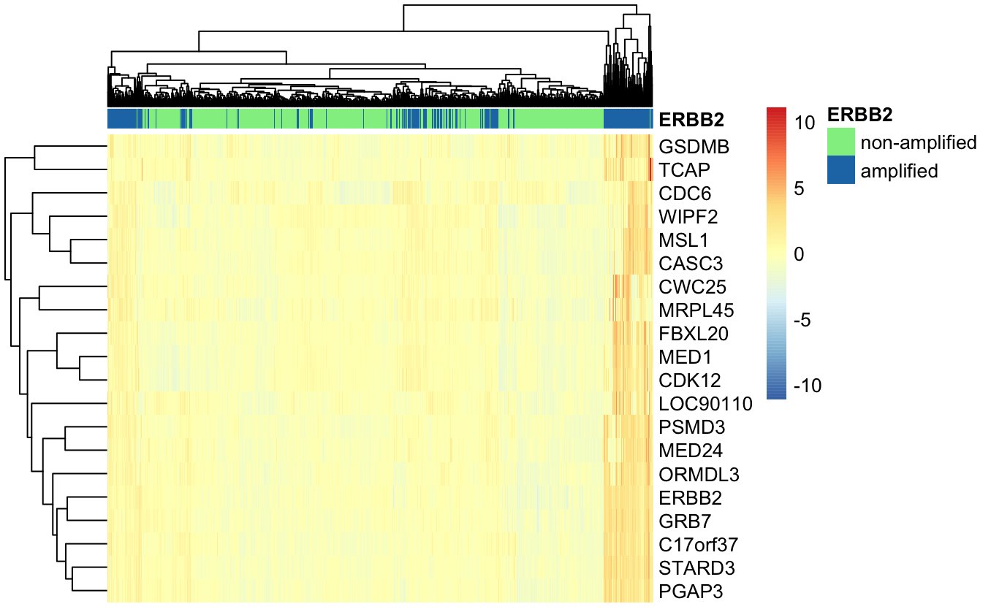
Figure 11. Heatmap of the Top 20 Differentially Expressed Genes Between ERBB2-Amplified (in blue) and Non-Amplified Tumors (in light green). Rows correspond to genes and columns correspond to tumor samples. Gene expression values were normalized and scaled by genes prior to visualization. Colors represent relative expression levels, with red indicating higher expression and blue indicating lower expression, as shown in the color scale.

The heatmap reveals overall higher expression of ERBB2 and associated genes in ERBB2-amplified samples. However, substantial heterogeneity is evident across clusters. Notably, ERBB2-amplified samples in the top-left cluster exhibit weaker expression compared with those in the top-right cluster, indicating differences in transcriptional output despite shared amplification status. This suggests that ERBB2 amplification alone does not uniformly dictate expression magnitude and that additional regulatory or genomic factors likely contribute to expression differences among amplified tumors.

Furthermore, the presence of multiple ERBB2-amplified clusters along the sample axis indicates that ERBB2 amplification does not fully separate samples into distinct groups. This observation is consistent with the PCA results, which showed low explained variance between ERBB2-amplified and non-amplified tumors.

On the gene axis, we can observe a distinct cluster containing ERBB2, GRB7, STARD3, PGAP3, and related genes. This co-expression pattern is consistent with chromosomal co-amplification of the 17q12 amplicon and supports the notion that coordinated overexpression of neighboring genes contributes to the HER2-positive transcriptional profile (Sahlberg et al., 2012).

3.4. Lasso Regularised Cox Regression with DE Genes
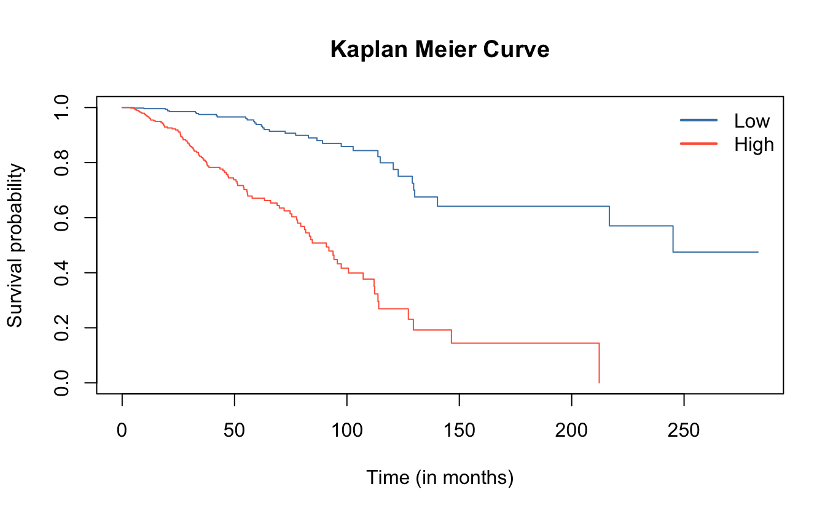
Figure 12. Kaplan-Meier Survival Curve for High and Low Risk Groups. The high risk group shows a significant decrease in survival rate as compared to the low risk group.
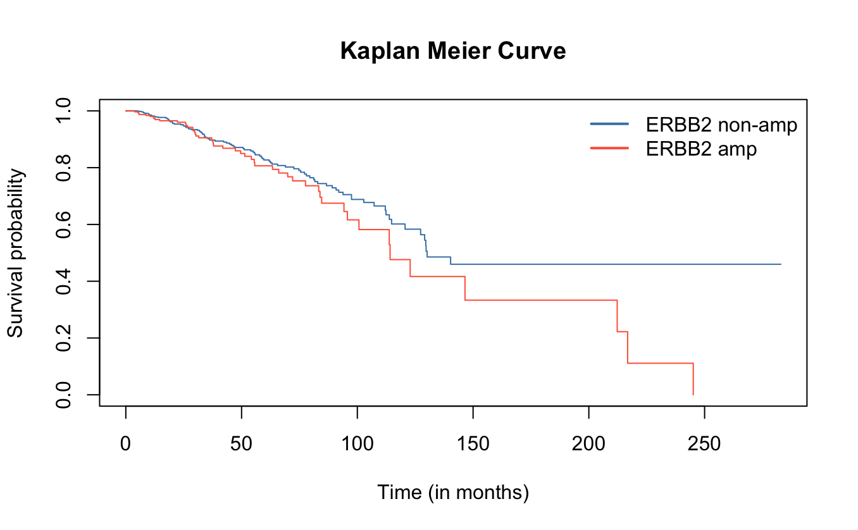
Figure 13. Kaplan-Meier Survival Curve for ERBB2-amplified and ERBB2-non-amplified Groups. Both groups seem to decrease in survival rate similar to each other from 0 to 150 months. After 150 months, there is slight divergence as the ERBB2-amplified group’s survival rate decreases faster.

Group | N | Observed | Expected | (O-E)^2/E | (O-E)^2/V
Low Risk | 528 | 37 | 94.3 | 34.8 | 100
High Risk | 527 | 111 | 53.7 | 61.2 | 100
Chisq= 100 on 1 degrees of freedom, p= <2e-16
Table 3. Summary of Log-Rank Test for Survival Differences Between Risk Groups

Group | N | Observed | Expected | (O-E)^2/E | (O-E)^2/V
ERBB2 non amplified | 731 | 99 | 107.5 | 0.67 | 2.47
ERBB2 amplified | 324 | 49 | 40.5 | 1.78 | 2.47
Chisq= 2.5 on 1 degrees of freedom, p= 0.1
Table 4. Summary of Log-Rank Test for Survival Differences Between ERBB2-amplified and ERBB2-non-amplified Groups.

Kaplan-Meier survival analysis revealed a clear distinction in overall survival between patients stratified by predicted risk. As shown in table 3, patients in the high-risk group experienced significantly poorer survival compared with the low-risk group ($χ² = 100, p = 2 × 10^{-16}$). The high-risk group exhibited more than 3 times the number of observed events relative to the low-risk group (111 vs. 37), indicating that the risk stratification captures clinically meaningful differences in patient outcomes.

In contrast, stratification based solely on ERBB2 amplification status did not yield a statistically significant difference in survival (Table 4; $χ² = 2.47, p = 0.1$). Although ERBB2-amplified patients showed a steep slope after 150 months, this difference was modest and insufficient to distinguish survival outcomes at the population level (Figure 13). These findings further support that ERBB2 amplification alone is not a strong independent predictor of overall survival in this cohort.

4. Discussion

4.1. Interesting KEGG Pathways
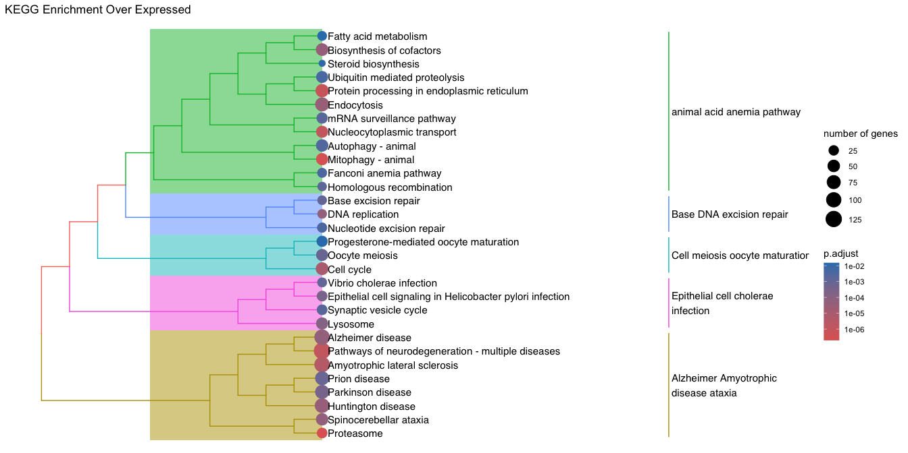
Figure 14. Hierarchical Clustering of KEGG Pathways Enriched Among Over-Expressed Genes. Each node represents a KEGG pathway, with node size proportional to the number of genes contributing to the enrichment. Node color indicates the adjusted p-value (Benjamini–Hochberg correction), with warmer colors corresponding to greater statistical significance. The dendrogram reflects pathway similarity based on shared gene content, and colored background blocks denote major pathway clusters. Pathway names are displayed on the right.

Several KEGG pathways annotated for neurodegenerative diseases, including Huntington disease and amyotrophic lateral sclerosis, were enriched among over-expressed genes. Although these pathways are not specific to breast cancer, they encompass genes involved in fundamental cellular processes such as oxidative stress responses, inflammation, mitochondrial dysfunction, and protein homeostasis. Their enrichment therefore likely reflects shared cellular stress and proteostatic mechanisms that are transcriptionally altered in cancer cells, rather than disease-specific neurodegenerative processes. While epidemiological studies have reported associations between cancer and motor neuron diseases, a direct mechanistic link remains unestablished (Chio et al., 1988; Kijima et al., 2005).

On the other hand, the enrichment of the biosynthesis of cofactors pathway likely reflects mitochondrial and metabolic reprogramming in breast cancer cells rather than a disease‑specific anemia phenotype (Lunetti et al., 2019). In figure 14, this pathway clusters with mitophagy, endocytosis, nucleocytoplasmic transport, and endoplasmic‑reticulum protein processing, indicating coordinated transcriptional regulation of mitochondrial quality control, intracellular trafficking, and proteostasis. Together, this cluster suggests broader metabolic and organelle‑level adaptations that help breast cancer cells maintain mitochondrial function and tolerate cellular stress.
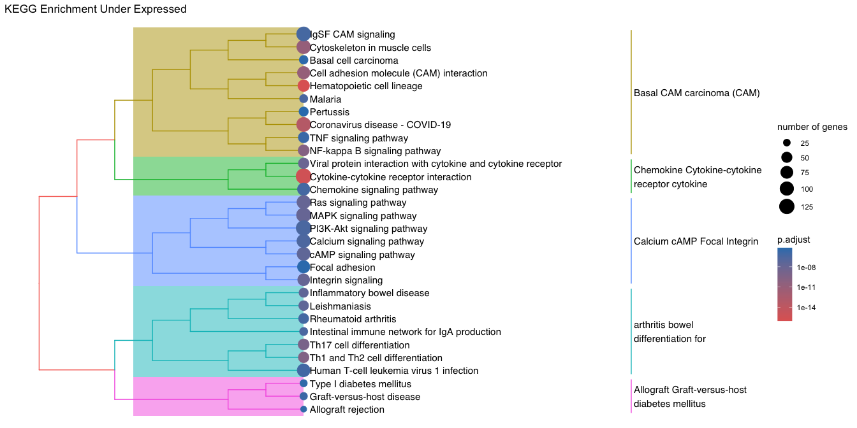Figure 15. Hierarchical Clustering of KEGG Pathways Enriched Among Under-Expressed Genes.

The Coronavirus disease (COVID-19) KEGG pathway, which clusters closely with hematopoietic cell lineage, NF-κB signaling, and cell-adhesion pathways in the enrichment tree, was significantly enriched among under-expressed genes (Figure 15). Although annotated in the context of viral infection, this pathway may comprise a broad set of immune and inflammatory response genes. Its co-clustering with immune pathways suggests that its enrichment reflects a general downregulation of some immune- and inflammation-related components in ERBB2-amplified tumors, rather than processes specific to Covid-19 infection.

The KEGG pathway Viral protein interaction with cytokine and cytokine receptor describes how viral proteins bind to, mimic, or modulate host cytokines and their receptors, thereby altering cytokine signalling and immune responses (Immunoway, 2024). In the context of breast cancer, this pathway is enriched alongside cytokine-cytokine receptor interaction, suggesting that the signal likely reflects altered expression of host cytokine and cytokine-receptor genes rather than viral activity (Figure 15). Therefore, the underexpression of some components of this pathway may indicate a dampened cytokine-mediated immune or inflammatory program within the tumor microenvironment.

Similarly, we can interpret the KEGG MAPK signaling pathway based on its position within the pathway clustering structure. The pathways clustering with MAPK signaling (including Ras signaling, PI3K-Akt signaling, calcium and cAMP signaling, integrin signaling, and focal adhesion) form an interconnected network of RTK-proximal signaling modules (Figure 15). The enrichment of these pathways among under-expressed genes likely indicates coordinated transcriptional remodeling and feedback regulation of the broader network.

4.2. Summary of Key Findings
1. Which genes are differentially expressed between HER2-amplified and non-amplified tumors?

First, differential expression analysis identified a distinct set of genes that are significantly upregulated in HER2-amplified tumors compared with non-amplified tumors. As expected, ERBB2 itself was among the most highly over-expressed genes. Importantly, several neighboring genes within the 17q12 amplicon (including GRB7, STARD3, PGAP3, PSMD3, C17orf37, and ORMDL3) were also consistently over-expressed, indicating coordinated transcriptional regulation driven by chromosomal co-amplification rather than isolated ERBB2 upregulation.

2. Which biological pathways are enriched among these genes?

Second, functional enrichment analyses revealed that genes over-expressed in ERBB2-amplified tumors are predominantly associated with cell-cycle progression, mitosis, DNA replication, proteostasis, autophagy, and intracellular trafficking, as demonstrated by GO, KEGG, and Reactome analyses. In contrast, genes under-expressed in ERBB2-amplified tumors were enriched for immune-related pathways, including T-cell activation, cytokine signaling, NF-κB signaling, and hematopoietic lineage pathways, suggesting transcriptional remodeling of immune and inflammatory programs.

3. How do these pathways contribute to oncogenic processes in HER2-positive breast cancer?

Finally, these enriched pathways provide insight into the oncogenic processes underlying HER2-positive breast cancer. Over-expression of cell-cycle, proteasome, and stress-adaptation pathways supports enhanced proliferation, replicative stress tolerance, and metabolic adaptation. Conversely, reduced expression of some components in immune-related pathways may reflect diminished immune infiltration or tumor-mediated immune evasion within the tumor microenvironment. In short, these findings indicate that HER2-positive breast cancer is characterized by coordinated activation of proliferative and survival-associated transcriptional programs alongside suppression of immune-related gene expression, contributing to tumor growth, progression, and therapeutic resistance.

4.2. Conclusion & Next Steps
Overall, ERBB2 amplification alone does not fully account for the observed patterns of differential gene expression. As demonstrated in the differential expression analysis, ERBB2 upregulation consistently co-occurs with coordinated changes in multiple neighboring and functionally related genes, forming a complex network of interacting transcriptional programs. The heatmap analysis and PCA further support this conclusion by revealing low variance explained and multiple ERBB2-amplified clusters with distinct expression profiles, indicating substantial heterogeneity within HER2-positive tumors.

These findings suggest that ERBB2 amplification acts within a broader molecular context shaped by co-amplified genes, downstream signaling pathways, and tumor microenvironmental factors. Consequently, variation in gene expression and clinical outcomes among ERBB2-amplified tumors is likely influenced by additional confounding variables, such as co-occurring genomic alterations, pathway-level regulation, immune infiltration, and treatment-related effects.

Future analyses should therefore go beyond ERBB2 status and incorporate approaches to better characterize this heterogeneity. We suggest the next steps to include multivariate survival modeling to identify prognostic contributors and stratification of ERBB2-amplified tumors into subgroups to further resolve network-level differences in transcriptional regulation and pathway activation underlying heterogeneous tumor phenotypes.

5. Github Repository Link
Please go to this repo to access detailed script for this analysis: https://github.com/v-iettran/Gene-Expression-Analysis

References
Barnieh, F.M., Morton, J., Olanrewaju, O. and El-Khamisy, S.F. (2025). Decoding the adaptive survival mechanisms of breast cancer dormancy. Oncogene. doi:https://doi.org/10.1038/s41388-025-03529-3.
Byers, H.A., Brooks, A.N., Vangala, J.R., Grible, J.M., Feygin, A., Clevenger, C.V., Harrell, J.C. and Radhakrishnan, S.K. (2023). Evaluation of the NRF1-proteasome axis as a therapeutic target in breast cancer. Scientific reports, [online] 13(1), p.15843. doi:https://doi.org/10.1038/s41598-023-43121-x.
Carlson, M. (n.d.). org.Hs.eg.db. [online] Bioconductor. Available at: https://bioconductor.org/packages/release/data/annotation/html/org.Hs.eg.db.html.
Chan, E.T. and Cömert Kural (2024). Targeting endocytosis to sensitize cancer cells to programmed cell death. Biochemical Society Transactions, 52(4), pp.1703–1713. doi:https://doi.org/10.1042/bst20231332.
Charman, M., Kennedy, B.E., Osborne, N. and Karten, B. (2010). MLN64 mediates egress of cholesterol from endosomes to mitochondria in the absence of functional Niemann-Pick Type C1 protein. Journal of Lipid Research, 51(5), pp.1023–1034. doi:https://doi.org/10.1194/jlr.m002345.
Chio, A., Brignolio, F., Meineri, P., Rosso, M.G., Tribolo, A. and Schiffer, D. (1988). Motor neuron disease and malignancies: results of a population-based study. Journal of Neurology, 235(6), pp.374–375. doi:https://doi.org/10.1007/bf00314238.
Cleveland Clinic (2023). Breast cancer: Causes, stage, diagnosis & treatment. [online] Cleveland Clinic. Available at: https://my.clevelandclinic.org/health/diseases/3986-breast-cancer.
Conforti, F., Wang, Y., Rodriguez, J.A., Alberobello, A.T., Zhang, Y.-W. and Giaccone, G. (2015). Molecular Pathways: Anticancer Activity by Inhibition of Nucleocytoplasmic Shuttling. Clinical Cancer Research, 21(20), pp.4508–4513. doi:https://doi.org/10.1158/1078-0432.ccr-15-0408.
Danilo, C. and Frank, P.G. (2012). Cholesterol and breast cancer development. Current Opinion in Pharmacology, 12(6), pp.677–682. doi:https://doi.org/10.1016/j.coph.2012.07.009.
Darang, E., Zahra Pezeshkian, Seyed Ziaeddin Mirhoseini and Shahrokh Ghovvati (2023). Bioinformatics and pathway enrichment analysis identified hub genes and potential biomarker for gastric cancer prognosis. Frontiers in Oncology, [online] 13. doi:https://doi.org/10.3389/fonc.2023.1187521.
Dasgupta, S., Cushman, I., Kpetemey, M., Casey, P.J. and Vishwanatha, J.K. (2011). Prenylated C17orf37 Induces Filopodia Formation to Promote Cell Migration and Metastasis. Journal of Biological Chemistry, 286(29), pp.25935–25946. doi:https://doi.org/10.1074/jbc.m111.254599.
Dasgupta, S., Wasson, L.M., N Rauniyar, L Prokai, J Borejdo and Vishwanatha, J.K. (2009). Novel gene C17orf37 in 17q12 amplicon promotes migration and invasion of prostate cancer cells. Oncogene, [online] 28(32), pp.2860–2872. doi:https://doi.org/10.1038/onc.2009.145.
Deepak, K., Roy, P.K., Das, C.K., Mukherjee, B. and Mandal, M. (2024). Mitophagy at the crossroads of cancer development: Exploring the role of mitophagy in tumor progression and therapy resistance. Biochimica et Biophysica Acta (BBA) - Molecular Cell Research, [online] 1871(6), p.119752. doi:https://doi.org/10.1016/j.bbamcr.2024.119752.
El Khoury, W. and Nasr, Z. (2021). Deregulation of ribosomal proteins in human cancers. Bioscience Reports, [online] 41(12). doi:https://doi.org/10.1042/bsr20211577.
Fattah, A., Khader, A.A., Ezidin Kaddumi, Maher Obeidat and O'la Al-Fawares (2021). Differential Expression and Prognostic Significance of STARD3 Gene in Breast Carcinoma. International journal of molecular and cellular medicine, [online] 10(1), pp.34–41. doi:https://doi.org/10.22088/ijmcm.bums.10.1.34.
Guo, H., Zhou, C., Zheng, M., Zhang, J., Wu, H., He, Q., Ding, L. and Yang, B. (2024). Insights into the role of derailed endocytic trafficking pathway in cancer: From the perspective of cancer hallmarks. Pharmacological Research, [online] 201, p.107084. doi:https://doi.org/10.1016/j.phrs.2024.107084.
Han, D.C., Shen, T.-L. and Guan, J.-L. (2001). The Grb7 family proteins: structure, interactions with other signaling molecules and potential cellular functions. Oncogene, 20(44), pp.6315–6321. doi:https://doi.org/10.1038/sj.onc.1204775.
Hanahan, D. and Weinberg, Robert A. (2011). Hallmarks of cancer: the next Generation. Cell, [online] 144(5), pp.646–674. doi:https://doi.org/10.1016/j.cell.2011.02.013.
Hao, N., Li, M., Wang, J., Song, Y., Zhao, Y., Zhang, L., Yang, X., Chen, L., Ma, J., Jia, Q. and Sui, F. (2023). High PGAP3 expression is associated with lymph node metastasis and low CD8+T cell in patients with HER2+ breast cancer. Pathology - Research and Practice, [online] 251, p.154890. doi:https://doi.org/10.1016/j.prp.2023.154890.
Hughes, D.J., Schomburg, L., Jenab, M., Biessy, C., Méplan, C., Moskal, A., Sun, Q., Demircan, K., Fedirko, V., Weiderpass, E., Mukhtar, M., Olsen, A., Tjønneland, A., Overvad, K., Schulze, M., Nøst, T.H., Skeie, G., Olsen, K.S., Ricceri, F. and Grioni, S. (2023). Prediagnostic selenium status, selenoprotein gene variants and association with breast cancer risk in a European cohort study. Free radical biology & medicine, [online] 209(Pt 2), pp.381–393. doi:https://doi.org/10.1016/j.freeradbiomed.2023.10.401.
Hung, M.-C., Schechter, A.L., Chevray, P.-Y.M., Stern, D.F. and Weinberg, R.A. (1986). Molecular cloning of the neu gene: absence of gross structural alteration in oncogenic alleles. Proceedings of the National Academy of Sciences of the United States of America, 83(2), pp.261–264. doi:https://doi.org/10.1073/pnas.83.2.261.
Immunoway (2024). Viral protein interaction with cytokine and cytokine receptor - Signaling molecules and interaction - Immunoway. [online] Immunoway.com. Available at: https://www.immunoway.com/index.php/Signalingmoleculesandinteraction/131.html [Accessed 20 Dec. 2025].
Jacot, W., Maryse Fiche, Zaman, K., Wolfer, A. and Lamy, P.-J. (2013). The HER2 amplicon in breast cancer: Topoisomerase IIA and beyond. 1836(1), pp.146–157. doi:https://doi.org/10.1016/j.bbcan.2013.04.004.
Kijima, Y., Heiji Yoshinaka, Higuchi, I., Tetsuhiro Owaki and Takashi Aikou (2005). A case of amyotrophic lateral sclerosis and breast cancer. Breast Cancer, 12(1), pp.57–59. doi:https://doi.org/10.2325/jbcs.12.57.
Korkaya, H., Liu, S. and Wicha, M.S. (2011). Breast cancer stem cells, cytokine networks, and the tumor microenvironment. Journal of Clinical Investigation, 121(10), pp.3804–3809. doi:https://doi.org/10.1172/jci57099.
Kotoula, V., Bobos, M., Alexopoulou, Z., Papadimitriou, C., Papadopoulou, K., Charalambous, E., Tsolaki, E., Xepapadakis, G., Nicolaou, I., Papaspirou, I., Aravantinos, G., Christodoulou, C., Efstratiou, I., Gogas, H. and Fountzilas, G. (2014). Adjusting Breast Cancer Patient Prognosis with Non-HER2-Gene Patterns on Chromosome 17. PLoS ONE, 9(8), p.e103707. doi:https://doi.org/10.1371/journal.pone.0103707.
Levy, J.M.M., Towers, C.G. and Thorburn, A. (2017). Targeting autophagy in cancer. Nature Reviews Cancer, 17(9), pp.528–542. doi:https://doi.org/10.1038/nrc.2017.53.
Liu, Y., Liu, H. and Xiong, Y. (2025). Metabolic pathway activation and immune microenvironment features in non-small cell lung cancer: insights from single-cell transcriptomics. Frontiers in Immunology, 16. doi:https://doi.org/10.3389/fimmu.2025.1546764.
Llaverias, G., Danilo, C., Mercier, I., Daumer, K., Capozza, F., Williams, T.M., Sotgia, F., Lisanti, M.P. and Frank, P.G. (2011). Role of Cholesterol in the Development and Progression of Breast Cancer. The American Journal of Pathology, 178(1), pp.402–412. doi:https://doi.org/10.1016/j.ajpath.2010.11.005.
Love, M.I., Huber, W. and Anders, S. (2014). Moderated estimation of fold change and dispersion for RNA-seq data with DESeq2. Genome Biology, 15(12), p.550. doi:https://doi.org/10.1186/s13059-014-0550-8.
Lunetti, P., Mariangela Di Giacomo, Vergara, D., Stefania De Domenico, Maffia, M., Zara, V., Capobianco, L. and Ferramosca, A. (2019). Metabolic reprogramming in breast cancer results in distinct mitochondrial bioenergetics between luminal and basal subtypes. FEBS Journal, 286(4), pp.688–709. doi:https://doi.org/10.1111/febs.14756.
Maarit Hölttä-Vuori, Fabien Alpy, Kimmo Tanhuanpää, Eija Jokitalo, Mutka, A.-L. and Ikonen, E. (2005). MLN64 Is Involved in Actin-mediated Dynamics of Late Endocytic Organelles. Molecular Biology of the Cell, 16(8), pp.3873–3886. doi:https://doi.org/10.1091/mbc.e04-12-1105.
Ma'ayan Laboratory of Computational Systems Biology (2016). Gene - PSMD3. [online] Maayanlab.cloud. Available at: https://maayanlab.cloud/Harmonizome/gene/PSMD3 [Accessed 19 Dec. 2025].
Mamoor, S. (2024a). ORMDL3 is differentially expressed in HER2+ breast cancer. [online] Research Gate. doi:https://doi.org/10.13140/RG.2.2.26100.77445.
Mamoor, S. (2024b). PGAP3 is differentially expressed in HER2+ breast cancer. [online] doi:https://doi.org/10.13140/rg.2.2.34489.38241.
Morris, C., Cluet, D. and Ricci, E.P. (2021). Ribosome dynamics and mRNA turnover, a complex relationship under constant cellular scrutiny. WIREs RNA, 12(6). doi:https://doi.org/10.1002/wrna.1658.
National Center for Biotechnology Information (2025a). ORMDL3 ORMDL sphingolipid biosynthesis regulator 3 [Homo sapiens (human)] - Gene - NCBI. [online] www.ncbi.nlm.nih.gov. Available at: https://www.ncbi.nlm.nih.gov/gene/94103.
National Center for Biotechnology Information (2025b). PGAP3 post-GPI attachment to proteins phospholipase 3 [Homo sapiens (human)] - Gene - NCBI. [online] Nih.gov. Available at: https://www.ncbi.nlm.nih.gov/gene/93210.
Pan, H., Wu, X., Hu, B., Xiong, H., Luo, Y. and Zhou, J.-K. (2025). Nonsense-mediated mRNA decay: a key regulatory system engaged in cancer. Cell Communication and Signaling, 23(1). doi:https://doi.org/10.1186/s12964-025-02503-6.
Pero, S.C., Oligino, L., Daly, R.J., Soden, A.L., Liu, C., Roller, P.P., Li, P. and Krag, D.N. (2002). Identification of Novel Non-phosphorylated Ligands, Which Bind Selectively to the SH2 Domain of Grb7. Journal of Biological Chemistry, 277(14), pp.11918–11926. doi:https://doi.org/10.1074/jbc.m111816200.
Reactome (2017). ZNF598 and the Ribosome-associated Quality Trigger (RQT) complex dissociate a ribosome stalled on a no-go mRNA. [online] Reactome.org. Available at: https://www.reactome.org/content/detail/R-HSA-9954716?utm_source=chatgpt.com [Accessed 20 Dec. 2025].
Sahlberg, K.K., Hongisto, V., Edgren, H., Mäkelä, R., Hellström, K., Due, E.U., Moen Vollan, H.K., Sahlberg, N., Wolf, M., Børresen-Dale, A.-L., Perälä, M. and Kallioniemi, O. (2012). The HER2 amplicon includes several genes required for the growth and survival of HER2 positive breast cancer cells. Molecular Oncology, 7(3), pp.392–401. doi:https://doi.org/10.1016/j.molonc.2012.10.012.
Salgado, R., Denkert, C., Demaria, S., Sirtaine, N., Klauschen, F., Pruneri, G., Wienert, S., Van den Eynden, G., Baehner, F.L., Penault-Llorca, F., Perez, E.A., Thompson, E.A., Symmans, W.F., Richardson, A.L., Brock, J., Criscitiello, C., Bailey, H., Ignatiadis, M., Floris, G. and Sparano, J. (2015). The evaluation of tumor-infiltrating lymphocytes (TILs) in breast cancer: recommendations by an International TILs Working Group 2014. Annals of Oncology, [online] 26(2), pp.259–271. doi:https://doi.org/10.1093/annonc/mdu450.
Shen, T.-L. and Guan, J.-L. (2001). Differential regulation of cell migration and cell cycle progression by FAK complexes with Src, PI3K, Grb7 and Grb2 in focal contacts. FEBS Letters, 499(1-2), pp.176–181. doi:https://doi.org/10.1016/s0014-5793(01)02545-5.
Shimada, B.K., Swanson, S., Toh, P. and Seale, L.A. (2022). Metabolism of Selenium, Selenocysteine, and Selenoproteins in Ferroptosis in Solid Tumor Cancers. Biomolecules, [online] 12(11), p.1581. doi:https://doi.org/10.3390/biom12111581.
Slamon, D.J., Godolphin, W., Jones, L.A., Holt, J.A., Wong, S.G., Keith, D.E., Levin, W.J., Stuart, S.G., Udove, J. and Ullrich, A. (1989). Studies of the HER-2/neu proto-oncogene in human breast and ovarian cancer. Science (New York, N.Y.), [online] 244(4905), pp.707–12. doi:https://doi.org/10.1126/science.2470152.
Stein, D.L., Wu, J., Fuqua, S.W., Roonprapunt, C., Vijay Yajnik, P D'Eustachio, Moskow, J.J., Buchberg, A.M., C. Kent Osborne and Margolis, B. (1994). The SH2 domain protein GRB-7 is co-amplified, overexpressed and in a tight complex with HER2 in breast cancer. The EMBO Journal, 13(6), pp.1331–1340. doi:https://doi.org/10.1002/j.1460-2075.1994.tb06386.x.
Tan, M., Yao, J. and Yu, D. (1997). Overexpression of the c-erbB-2 gene enhanced intrinsic metastasis potential in human breast cancer cells without increasing their transformation abilities. Cancer research, [online] 57(6), pp.1199–205. Available at: https://pubmed.ncbi.nlm.nih.gov/9067293/.
Tan, M. and Yu, D. (2013). Molecular Mechanisms of ErbB2-Mediated Breast Cancer Chemoresistance. [online] www.ncbi.nlm.nih.gov. Landes Bioscience. Available at: https://www.ncbi.nlm.nih.gov/books/NBK6194/.
Tecalco-Cruz, A.C., Pérez-Alvarado, I.A., Ramírez-Jarquín, J.O. and Rocha-Zavaleta, L. (2017). Nucleo-cytoplasmic transport of estrogen receptor alpha in breast cancer cells. Cellular Signalling, 34, pp.121–132. doi:https://doi.org/10.1016/j.cellsig.2017.03.011.
Ubellacker, J.M., Baryawno, N., Severe, N., DeCristo, M.J., Sceneay, J., Hutchinson, J.N., Haider, M.-T., Rhee, C.S., Qin, Y., Gregory, W.M., Garrido-Castro, A.C., Holen, I., Brown, J.E., Coleman, R.E., Scadden, D.T. and McAllister, S.S. (2018). Modulating Bone Marrow Hematopoietic Lineage Potential to Prevent Bone Metastasis in Breast Cancer. Cancer Research, [online] 78(18), pp.5300–5314. doi:https://doi.org/10.1158/0008-5472.can-18-0548.
White, E., Lattime, E.C. and Guo, J.Y. (2021). Autophagy Regulates Stress Responses, Metabolism, and Anticancer Immunity. Trends in Cancer, 7(8), pp.778–789. doi:https://doi.org/10.1016/j.trecan.2021.05.003.
WHO (2025). Breast cancer. [online] World Health Organization. Available at: https://www.who.int/news-room/fact-sheets/detail/breast-cancer.
Xu, S., Hu, E., Cai, Y., Xie, Z., Luo, X., Zhan, L., Tang, W., Wang, Q., Liu, B., Wang, R., Xie, W., Wu, T., Xie, L. and Yu, G. (2024). Using clusterProfiler to characterize multiomics data. Nature Protocols, [online] 19. doi:https://doi.org/10.1038/s41596-024-01020-z.
Yarwood, R., Hellicar, J., Woodman, P.G. and Lowe, M. (2020). Membrane trafficking in health and disease. Disease Models & Mechanisms, [online] 13(4). doi:https://doi.org/10.1242/dmm.043448.
Yu, G. (2025). Visualization of Functional Enrichment Result. [online] Bioconductor. Available at: https://bioconductor.org/packages/release/bioc/html/enrichplot.html.
Yu, G. and He, Q.-Y. (2016). ReactomePA: an R/Bioconductor package for reactome pathway analysis and visualization. Molecular BioSystems, 12(2), pp.477–479. doi:https://doi.org/10.1039/c5mb00663e.

AI/LLM Usage Declaration for Assignment 2 Submission
Student Name: Viet Tran
Student Number: 25216938
Instructions
- You must complete the declaration below and include it at the end of your submitted assignment.
- This declaration clarifies which components of your work were completed independently and which, if any, involved permitted forms of AI/LLM assistance.
- Read the Table carefully and ensure your work adheres to the permitted uses.
- Any use of AI/LLM beyond what is allowed must be explicitly disclosed.
- Relevant information on GenAI use can be found at https://www.ucd.ie/teaching/resources/generativeai/genaiucd/
- Full AI/LLM mode for producing this assignment is not permitted.
- Tick the relevant box below the Table to indicate whether you:
- did not used AI/LLM,
- used it in collaborative mode, or
- used it in full AI/LLM mode.
- The assignment components in the Table are numbered. Indicate the relevant numbers for each mode you declare.
 | ASSIGNMENT COMPONENT | No AI/LLM | Collaborative AI/LLM
1 | Introduction & literature review | Written independently by the student, demonstrating critical synthesis of relevant papers. | Used for summarisation of cited papers, as a starting point, checking sentence structure, or ensuring proper citation style.
2 | Results & figures (DEG, pathway enrichment, PCA plot interpretation) | All analytical text is written by the student, describing and explaining their specific results. | Used to format tables of results, check grammar and style, or generate preliminary descriptions analysis.
3 | Core script (data loading, deseq2, vst, pca, heatmap, cox regression) | Written from scratch by the student. | Used as a coding assistant. Student must write all core logic.
4 | Discussion & interpretation (emphasis on biological insight) | Demonstrates deep understanding by linking specific findings to cited biological literature. | Used for refining clarity and tone or suggesting alternative phrasing for complex biological concepts.
5 | GitHub/readme file | Student written descriptions of the code structure and functions. | Used to check spelling, grammar, and markdown formatting of the README file.

I declare that:
- I used no AI/LLM tools in the preparation of assignment components numbers: 1, 3, 4
- I used AI/LLM tools in collaborative mode in the preparation of assignment components numbers: 2, 5
- I used AI/LLM tools in full mode for assignment components numbers: N/A

